Bahria University,

Karachi Campus



LAB EXPERIMENT NO.

**08**

LIST OF TASKS

|  |  |
| --- | --- |
| TASK NO | OBJECTIVE |
| 1 | **Create an arrow function that takes two parameter length and width, then return the product of these two parameters to calculate the area of a rectangle.** |
| 2 | **Create an array of numbers from 1 to 10 and create an arrow function that takes an integer parameter, the arrow function will find whether the parameter value is present in an array or not. If the value is found, return the index at which the value is found, else print “The value does not exist in the array”.** |
| 3 | **Create an array which contains your desired values, then using an arrow function, sum all the elements in that array and save the resulting answer in any variable, then create another array with your desired values and multiply all its elements using an arrow function and save the result of the multiplied array elements in any variable, then divide both results and using promises, resolve if the answer is in floating point, and reject if it is not.** |
| 4 | **Create an arrow function to test if an argument is infinity** |
| 5 | **Create a JavaScript set of letters, and add a – z letters in it** |

Submitted On:

**Task 01: Create an arrow function that takes two parameter length and width, then return the product of these two parameters to calculate the area of a rectangle.**

**Solution:**

let Area = (length, width) => {

    return length * width

}

console.log("Area Of Rectangle : " + Area(2, 2))

**Output:**

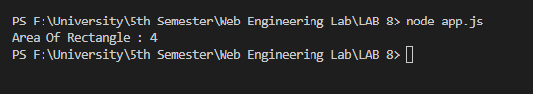

**Task 02: Create an array of numbers from 1 to 10 and create an arrow function that takes an integer parameter, the arrow function will find whether the parameter value is present in an array or not. If the value is found, return the index at which the value is found, else print “The value does not exist in the array”.**

**Solution:**

const arr=[1,2,3,4,5,6,7,8,9,10]

let Check=(num)=>{

    let isfound=false,ind=null

    for(let i=0;i<10;i++){

        if(num==arr[i]){

            isfound=true

            ind=i

        }

    }

    if(isfound){

        return num + " Found At Index " + ind

    }

    else{

        return num + "Not Found"

    }

}

console.log(Check(5))

console.log(Check(10))

**Output:**

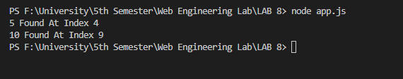

**Task 03: Create an array which contains your desired values, then using an arrow function, sum all the elements in that array and save the resulting answer in any variable, then create another array with your desired values and multiply all its elements using an arrow function and save the result of the multiplied array elements in any variable, then divide both results and using promises, resolve if the answer is in floating point, and reject if it is not.  
  
Solution:**

let arr1=[2,4,8,10,12]

let arr2=[12,10,8,6,4]

let SumA=(arr)=>{

    let sum=0

    for(let i=0;i<arr.length;i++){

        sum+=arr[i]

    }

    return sum

}

let productA=(arr)=>{

    let mul=1

    for(let i=0;i<arr.length;i++){

        mul*=arr[i]

    }

    return mul

}

console.log("Array 1:")

console.log(arr1)

console.log("Sum Of Array 1: " + SumA(arr1)+"\n")

console.log("Array 2:")

console.log(arr2)

console.log("Product Of Array 2: "+productA(arr2)+"\n")

let res=SumA(arr1)/productA(arr2)

const proms= new Promise((resolve, reject) => {

        if (!(Math.floor(res)==Math.ceil(res))) {

            resolve ('Promise is resolved successfully. The result is ' +res)

        } else {

            reject ('Promise Is Rejected')

        }

});

proms.then((result) => {

    console.log(result)

})

.catch(function(error){

    console.log(error)

});

**Output:**

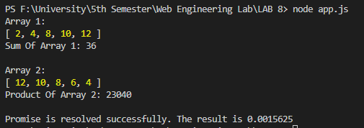

**Task 04: Create an arrow function to test, if an argument is infinity**

**Solution:**let Check=(val)=>{

    if(!isNaN(val)){

        if(!isFinite(val)){

            console.log("Infinite Number");

        }

        else{

            console.log("Finite Number");

        }

    }

    else{

        console.log("Not A Number");

    }

}

console.log("Entering \"Infinity\"");

Check(Infinity)

console.log("Entering \"10\"");

Check(10)

**Output:**

**Task 05: Create a JavaScript set of letters, and add a – z letters in it**

**Solution:**let i;

i = 97;

const letters = new Set();

while (i <= 122) {

    letters.add(String.fromCharCode(i));

    i++;

}

console.log(letters)

**Output:**

